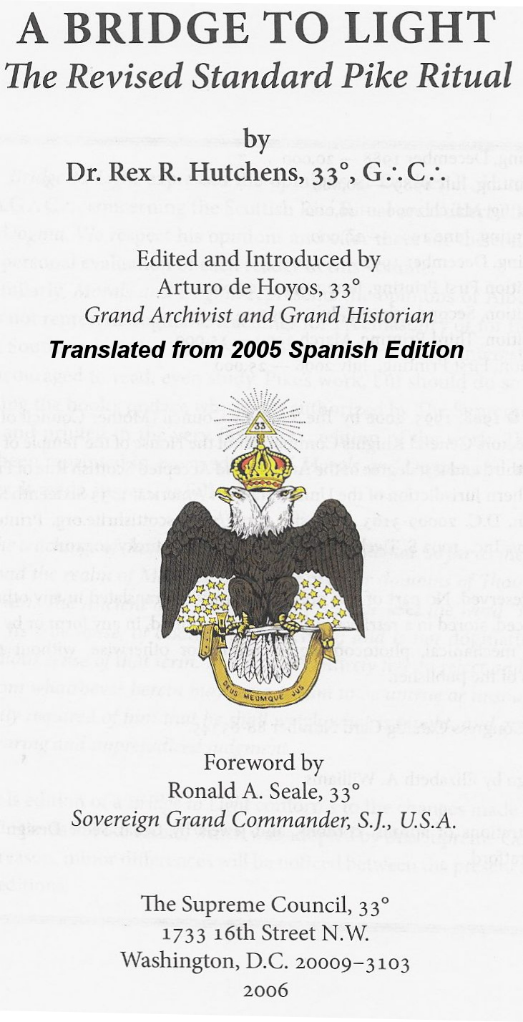

Page 1
Translation of Spanish A Bridge to Light INDEX
General introduction …………………………………………………… . 2
Introduction to the ineffable degrees …………………………………… 6
4th Degree: Secret Master ………………………………………… .. 10
5th Degree: Perfect Master ………………………………………… 16
6th Degree: Intimate Secretary ………………………………………… 21
7th Degree: Provost and Judge ………………………………………… ... 27
8th Degree: Building Intendant …………………………… ... 32
9th Degree: Chosen Master of the Nine ………………………… . 38
10th Degree: Chosen Master of the Fifteen ………………………… 44
11th Degree: Knight Chosen or Chosen of the Twelve ……………… 50
12th Degree: Grand Master Architect ……………………………… .. 55
13th Degree: Royal Arch ………………………………………………… . 61
14th Degree: Great Chosen, Perfect and Sublime Mason …………… ... 67
Introduction to the Chapter degrees ………………………………… . 79
15th Degree: Knight of the East of the Sword or the Eagle ……… 83
16th Degree: Prince of Jerusalem …………………………………… . 89
17th Degree: Knight of the East and West ………………… .. 95
18th Degree: Sovereign Prince Rosa Cruz …………………… ......... 100
19th Degree: Grand Pontiff ………………………………………… ... 112
20th Degree: Ad-Vitam or Symbolic Lodge Master ………… . 118
21st Degree: Patriarch Noachite …………………………………… ... 124
22nd Degree: Prince of Lebanon …………………………………… ... 129
23rd Degree: Head of the Tabernacle …………………………………… . 134
24th Degree: Prince of the Tabernacle ……………………………… . 140
25th Degree: Knight of the Brazen Serpent ………………… ... 148
26th Degree: Prince of Mercy missing
27th Degree: Sovereign Commander of the Temple missing
28th Degree: Knight of the Sun or Prince Adept missing
29th Degree: Scottish Grand Knight of Saint Andrew of Scotland missing
30th Degree: Knight Kadosh 999
31st Degree: Grand Commander Inspector missing
32nd Degree: Sublime Prince of the Royal Secret 999
33rd Degree: Sovereign Grand Inspector General missing
COVER …………………………………………………………… . 159
1

INTRODUCTION

Modern speculative Freemasonry did not leap onto the historical stage at a meeting of the Lodge of Antiquity at Goose and Casserole Tavern or of the Grand Lodge of England at Apple Tree Tavern in 1717. The operative Masons had already contributed a rich legacy of symbolism and tradition that continues to enrich the Order to this day. There have also been persistent references in Masonic literature to possible relationships between Masonry and other systems that use symbolic language: the Rosicrucians, the Illuminati, Gnostics, Alchemists, Egyptians, Greeks, Romans, Christians, Essenes, Persians, Hindus, and Kabbalists.

Whether these alleged relationships demonstrate a continuing heritage, of which modern Freemasonry is the linear successor, or a mere emulation, is the central question of Masonic historical research. Whatever the truth of the story, Freemasonry's contributions to symbolism by the religions, philosophies, mythologies, and hidden mysteries of the past lie beneath its surface for all to see.

Rather than being a secret society, Freemasonry is a revealer of secrets. The great truths of ancient man were in their time great secrets too and few were admitted to the sanctuaries where these truths were taught. Today the Order teaches these great truths to all deserving men who ask to learn them. Many of these truths are taught in the Degrees of the Symbolic Lodges; many more, in the various Rites that have arisen in the course of Masonic History.

One such Rite was called Perfection, originally formed in France in the mid-18th century. It consisted of 25 Degrees, including the first three conferred by the Symbolic Lodges. When this Rite migrated to America and settled in South Carolina, it was expanded to 33 Degrees.

On may 11, 1801 the Supreme American Council of the Ancient and Accepted Scottish Rite was formed. Between that time and the appointment of Albert Pike as Sovereign Grand Commander in 1859 the Rite showed moderate and reasonable growth, until it reached a sudden decline that resulted in its virtual extinction. Thus Dr. Albert Mackey, Grand Secretary General of the Supreme Council, desperately came to Albert Pike for help, who was a journalist, Teacher, lawyer, soldier, poet and one of the greatest natural leaders of the South. Pike immediately began working to improve the rituals of the Degrees and the Statutes of Rite. All Scottish Rite Masons have seen, and many have read, the results of this great effort and the whole world has seen the fruit of this labor.

Pike's reviews of the Scottish Rite Degrees graphically portray the slow and painful process by which the civil thoughts, ideals, laws and institutions of modern society have grown and developed outside of religions, schools mystics, superstitions, inquisitions and persecutions of the past centuries.

He considered the Scottish Rite to be, as is all Freemasonry, a means of instruction. The subjects of that instruction are political, moral and religious philosophies. The means of instruction are the exemplification of the Degrees and certain readings designed to expand and explain the duties taught by the Degrees. These readings were, like the Degrees, written or compiled by Pike; and he tried to get the two to work together to give the instruction of the Rite. The readings consist of the lessons for the Degrees contained in Morals and Dogma and some additional material in small volumes Legends and Lectures. Morals and Dogma was traditionally given to the candidate as a gift at their reception to the 14th Degree.

Always difficult, the changes in educational emphasis in America made the Morals and Dogma readings almost incomprehensible to many. For this reason, after 1974 the text was no longer delivered to the candidates. This was, in some respects, an unfortunate decision. Contained in these pages are some of the most profound teachings of the Rite. At least partially as a result of their complexity, few books have been so widely distributed and so rarely read. The wisdom of Morals and Dogma is a fruit in the middle of the brambles and few have the patience to taste it. The result is that its clearest passages are ignored as are the pearls of Masonic beauty found within it, sparkling but unnoticed and worse still, unappreciated.

It can be said with certainty that today the Degrees alone constitute the only means of instruction. The disadvantages of such a situation are obvious: Degrees are not presented uniformly throughout the Jurisdiction, important symbols and lessons have been dispensed in the interest of saving time, and core systems are often inadequate. Even prominent members may not clearly understand what they are supposed to be teaching. Sincere Scottish Rite Masons may frequently attend meetings and observe the same Degrees many times, yet important lessons may be misunderstood or not understood at all. There is, in fact, no simple solution to these problems, because coupled with them is the wide variety of intentions that motivate Masons to seek admission to the Rite. Many have little interest in more than an elementary course of understanding its teachings

These teachings are not a random set of moral precepts, but rather an organized and coherent system of doctrine concerning the perfectibility of human behavior. This perfectibility is not an expectation of the achievement of perfection itself. It is a goal that, due to its clear impossibility, can be maintained by providing us with a goal for improvement. No man can be perfect, but he can strive for perfection and thus constantly improve his nature. Pike expresses this idea in Morals and Dogma: “Step by step men must advance towards Perfection and each Masonic Degree is supposed to be one of those steps” (p. 136) and “… towards that state and spirit of perfection,… all the good men of the earth tend ”(p. 538). In the Legend for the 32nd Degree he further says, “the Masonic Light, like daylight at the end of a long night in remote northern climates, it must come, not all in a flash, but in slow and imperceptible degrees ”(p. 5). To become a Scottish Rite Mason is to begin the search for philosophical truth in three areas: political, moral and religious. These areas express our duty towards God, towards our Country and towards Humanity.

The following diagram illustrates the Scottish Rite concept of the path to perfection or perhaps more accurately to wholeness.

FREEMASONRY

PHILOSOPHY → REALIZED IN → ACTION DUTY
TO GOD | TO COUNTRY | TO MAN
VENERATION | SERVICE | LOVE

The complete man has the balance and its religious, political and moral dimensions. To achieve this balance, man must move towards the spiritual security that makes it possible and this effort must be made in discreet steps. In the Scottish Rite we call these steps "Degrees". A Degree, properly received, enhances a man's sense of duty and prepares him for a greater understanding of his place and purpose in the Universe.

Duty within the Scottish Rite system is based on some form of action. It is not enough to know and understand; a Mason must consciously and conscientiously improve himself and the world in which he lives. We see Pike express this idea in his reading for the 16th Degree, Prince of Jerusalem:

What we do in our rest intervals, our going to church, our reading of books, is specially designed to prepare our minds for the action of life. We must listen and read and meditate so that we can act

good; and the action of life is itself the great field of spiritual improvement (p. 243).

Such This thing, of course, requires great effort, but what is won lightly is lightly appreciated. The teachings of the Rite were designed in such a way that no one would come out entirely ignorant and no one could fully dominate them in their lifetime. Our lessons are a feast for the mind but there are no waiters - you must serve yourself; peck here and there or take part with all your heart. The job is yours, and so is the reward.

This book was devised to act as a bridge between the ceremonies of the Degrees and the readings of Morals and Dogma. Taken in isolation, each is fragmentary and incomplete. Furthermore, it may be necessary to see the dramatic performances (rituals) several times before the teachings are fully understood. There may be the same need for repetition when studying the Morals and Dogma readings. Great will be the reward for the one who persists in his effort, however, and the result may be a clearer understanding of Masonic culture.

Summaries of the Degree Structure

Each of these summaries is organized in a similar way. The Degree ceremony is revised to the extent necessary and should not be considered a substitute for regular attendance at meetings and depriving yourself of the opportunity to observe the Degrees being performed. These reviews are intended to increase familiarity with the Symbols and the Story so that the enjoyment of the performance can be enhanced. Those who take part in the various performances of the Degree are also expected to take advantage of these summaries to gain a more complete understanding of the purpose of the Degrees and their places in them. Where appropriate for the understanding of a Degree, historical notes are added. Following the discussion of the ceremony, the reading of Morals and Dogma is explained. Each summary ends with a review of the duties and lessons of that particular Degree contained in Morales and Dogma. It is important not to forget that DUTIES and lessons are often found both in rituals and in readings

.

INTRODUCTION TO INEFFABLE DEGREES

These Degrees, from 4th to 14th are called Ineffable because their main purpose is the investigation and contemplation of the ineffable name of the Deity. The word "ineffable" is derived from the Latin ineffabilis which means something that should not be said. As used in these Degrees, it refers to the ancient Judaism belief that the name of God should not be spoken. This concept forms a metaphor for the Scottish Rite that teaches that the essential qualities of Deity are not capable of being described in words. Pike expresses this well in the 14th Degree reading:

Deity is therefore not an object of knowledge, but of faith; not to be understood by the understanding, but by the moral sense; not to be conceived, but to be felt (p. 222).

In the 28th Degree reading Pike suggests that the inconceivability of God forces us to critically accept any human description that may be as inaccurate as our own.

Why should we attempt to confine the idea of ​​the Supreme Mind within an arbitrary barrier, or exclude from the limits of truthfulness any conception of Deity, which while imperfect and inadequate, may be only slightly more so than our own? ? (pp. 650-651).

Therefore, as you reflect on the teachings of these Degrees, weigh your own limits of expression and understanding rather than those of others and

Begin now to ascend to the heavens of spiritual knowledge ...

Before beginning the ascent, three topics of greatest interest in the Ineffable Degrees should be reviewed - the Legend of Hiram and the concepts of Deity and the Lost Word.

The Legend of Hiram

The Ineffable Degrees of the Scottish Rite are built on the Legend that forms the basis of the Ritual of the Third Degree of Symbolic Lodges.

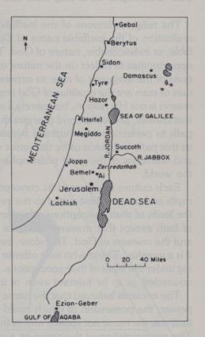
Before reviewing that legend and its elaborations of the Scottish Rite, it should be made clear about the difference between factual history and Masonic Tradition. The phrase "Masonic Tradition" suggests to us that it is an indication that we are not very interested in the details of the historical fact, as we are with the opportunities for symbolic instruction provided in the historical narrative. Thus, the Biblical account of Hiram's story occasionally differs from the Legend narrated in Masonic instruction. For example, we are told in 1 Kings 7:40 that Hiram finished all the work for which he had been commissioned by King Solomon and presumably returned to his home country, but the Masonic tradition recounts the death of Hiram during the construction of the Temple. Pike explains what Hiram is for Masonry:

Whoever Hiram really was, he is the type, perhaps an imaginary type, for us, of humanity in its highest phase; a
exemplary of what man can and should become, in the course of time, in his advance towards the realization of his destiny; an individual endowed with a glorious intellect, a noble soul, a fine organization, and a perfectly balanced moral being; a model of what humanity can be, and of what we believe it will be in the future good time of God; the possibility of race made real (p. 225).

The Ineffable Degrees continue to elaborate this legend Masonic, occasionally extracting from the Bible certain portions that are beneficially used to create characters, settings and themes.

Master Hiram's death is staged at an appropriate time and then the work is continued in the House of the Lord with the responsibilities of Hiram's duties being divided among several of his best companions. Likewise, the search for the murderers begins, all of whom are captured and receive just punishment for their evil.

The aspects of the legend that have to do with Solomon and the Temple are later mixed with an even older legend that has to do with Enoch, one of the first Hebrew patriarchs. It is discovered that the Temple of Solomon has been built near the ruins of an ancient Temple erected by Enoch and a Secret Chamber is discovered that is part of that original Temple.

The legend of the Ineffable Degrees concludes in triumph and disaster: the Temple is concluded, the sacred name of the Deity discovered, and the Perfect Chosen are created; Solomon, however, strays from the ways of the Lord and begins to make sacrifices to other gods in high places and most of the people follow him in this apostasy. The Perfectly Elect maintain true faith in the face of adversity and persist in transmitting with scrupulous purity the knowledge of the True God. As punishment for the people for turning their backs on God, Israel is conquered by Nebuchadnezzar and the Jews are taken captive to Babylon. The Temple, so spacious and magnificent, does not escape the fierce onslaught of barbarian forces. The sacred vessels are stolen and the immense bronze columns, Jakin and Boaz,

The legend continues in the Rose Cross Degrees of Knight of the East and Prince of Jerusalem where the circumstances surrounding the construction of the Second Temple form the ritualistic basis of the component lessons. For the Jews the Temples served as symbols of their covenant with God, as well as reminders of the alternate cycles of disobedience, punishment and moral resurrection of the Hebrew people; for us they are symbols of perfection and beauty.

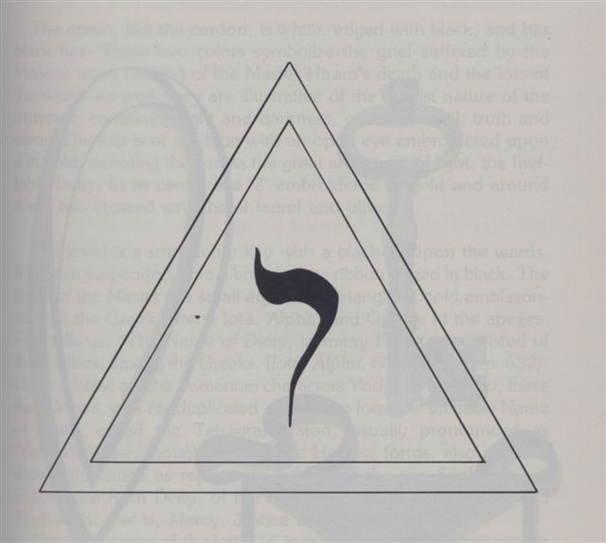
The Concepts of Deity and the Lost Word

The religious lessons of the Ineffable Degrees culminate in the realization of the ineffable name of Deity as a symbol of the ineffable, or indecipherable, nature of God. These Degrees provide many opportunities to reflect on the nature of God and the innate limitations of man's language to express the inexpressible. The virtues of man are the qualities of God imperfectly demonstrated. Our reason is not His reason, but hardly a mirror of the limitless mind that creates, preserves, and changes the Universe. We travel the path of perfection with humility because He has seen it fair to show us that path and guide us along the safest route, manifested in the lives and teachings of the great philosophers, teachers and prophets of the world.

Each culture has formed its conception of God within a particular myth and practice best suited to people's experiences and the limits of their conceptions. Masonry does not seek to teach any doctrine of faith, except that universal doctrine of the Brotherhood of Man and the Oneness of God. Therefore, although it is not a religion, it is a creed. Those who are offended by this are themselves working under the limitations of their
conceptions. That is why Brother Pike has wisely counseled us to be tolerant even of intolerance.

The Ancients believed that the name of God possessed a peculiar power, the possession of which could be used for better or for worse, so that the name was not pronounced and its true sound was lost forever. The pronunciation of the name as a search in Masonry should not be misinterpreted as a search for that power; it is rather a quest to understand that power that can, by the same inexorable law of nature, keep the planets on their courses and destroy lives as buildings fall in an earthquake. Just as physical evils are but the shadow of the light of nature, so moral evil is but the shadow of virtue. Masonry seeks to give a way out of that shadow so that we can be in the full light of the glory of God,

The Lost Word represents the name of God, the power of God and the ineffable nature of God. In the chapter on Degrees Rosa Cruz, she is also representative of the loss of moral sense in people. The Lost Word is saved for posterity in the hearts and minds of a very few whose perseverance and dedication to the principles of brotherhood have endowed Masonry with righteous models and sublime lessons.

